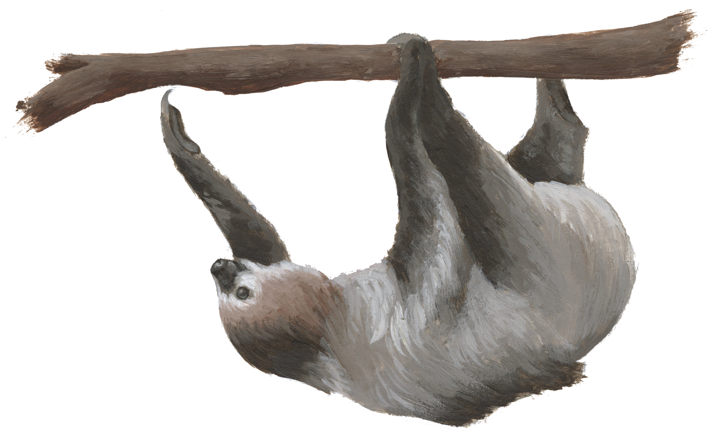
Trail of the Sloth
By Tom J. McConnell

Sloths are very unusual animals! Most people think of them as cute, but they are very specialized for their habitats, and they are more diverse than you might realize! Do you know that there are six different species of sloths? And do you know where they live?

Driving Question: Where do the different sloth species live?
Objectives:
- I can ask questions that can be answered with data.
- I can access a database of observations and data.
- I can notice patterns in data.
- I can create a map comparing habitats of different kinds of sloths.

You may know that there are two major groups of sloth species. Two of the sloth species are called “two-fingered” sloths because they have two toes on each front limb. The four species of “three-fingered” sloths have three fingers on each front limb. Sloth experts know that not all species of sloths can be found in the same area. While all wild sloths are found in Central and South America, each species has its own range. Scientists are also concerned that the number of sloths is declining, in large part because of the loss of their habitat. That means it is very important to understand what the range and habitat needs are for all the species of sloths.

In this activity, you will be the scientist by looking at real observations that other people are recording in a database called “iNaturalist.” This tool will let you see lots of information reported by people who see sloths in the wild, including the species, the habitat, the location on a map, and more!

Download iNaturalist
The first step is to download iNaturalist. This app is FREE, and they will not send you information you do not ask for. Have an adult help to access the site and set up your account. They can check for security concerns.

iNaturalist is available from your app store for both Mac and Android smartphones and tablets. You can also use a computer to view the site at https://inaturalist.org.

When you have downloaded the site or reach the web page, create your own account. Follow the steps on the website or app. Then on the next page, follow the instructions to find data to help answer your own questions.

Finding Sloth Data in iNaturalist

iNaturalist is a “citizen science” site that lets you post photos of living things, identify them, and share with other people. When you post an observation, other viewers may either confirm or correct your identification. The data in the site is used by professional scientists to get large amounts of data about animal habitats, location, population numbers, and other information.

For this activity, you will “Explore” the data others have posted.

Procedure:
- Log onto iNaturalist on your smartphone, tablet or computer. See page 1 for instructions for installing or accessing on the computer. Use your account login and password.
- Click on the “Explore” tab in the top row menu.
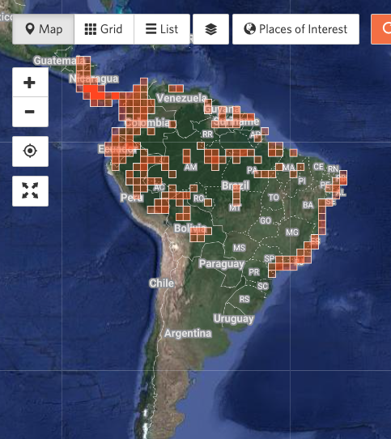
- When the world map loads, type “Sloth” into the “species” box in the search bar. You will see a list of several groups of species. Click the one that says “Extant Sloths.” The word “Extant” means that it is still alive in the wild. This search will not include two groups of extinct giant ground sloths.
- The map will show colored pixels where sloths have been observed. Use the + and – buttons to the left to zoom in or zoom out, and look more closely at the area where sloths live.
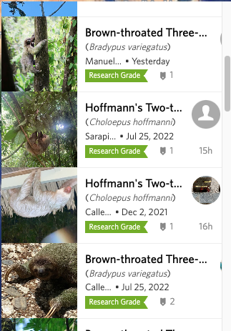

- You will also see a list of sloth observations that tell you what species or subspecies of giraffe the observer found. This can give you more information about each kind of sloth. You can also search for a specific species, like “brown-throated sloth.”
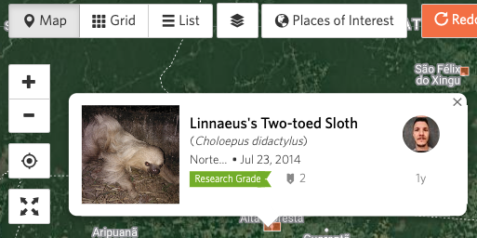
- When you zoom in far enough, you can click an individual orang pixel to see more information about that observation.

If you double click on the observation on this image, you can get more details (see image below.) This information includes the photograph of that animal, a map of the location, and any confirmation from others that this is the correct species.

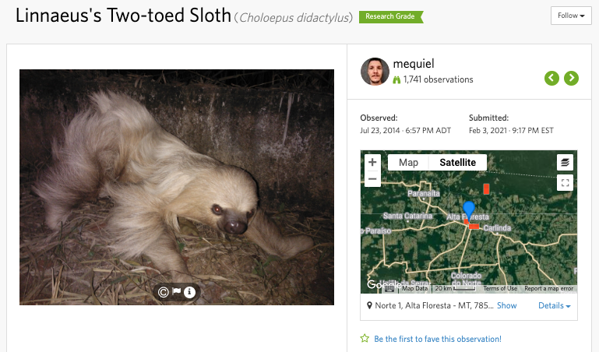

Mapping Sloths and Asking Your Own Questions!

Now you know how to FIND information. It’s time to BE the scientist!! Start on the Page 4 by mapping out where you find different species of sloths. You may eventually notice a pattern on the map that tells you more about sloths!

Then you can ask your own questions using the template on Page 5. Then use the information in iNaturalist to get the data you need to help answer your questions!

You can also learn more about sloths by reading Conservation Tales: Sloths!

Mapping Sloth Observations

Driving Question: Where do the different sloth species live?

On the map of Central and South America below, put colored dots on the areas where you find each species of sloth. You get to pick what colors to use! Make sure you color in the “key” that tells what color represents each kind of sloth. For any sloths you find with no species name, use “uncertain species.”
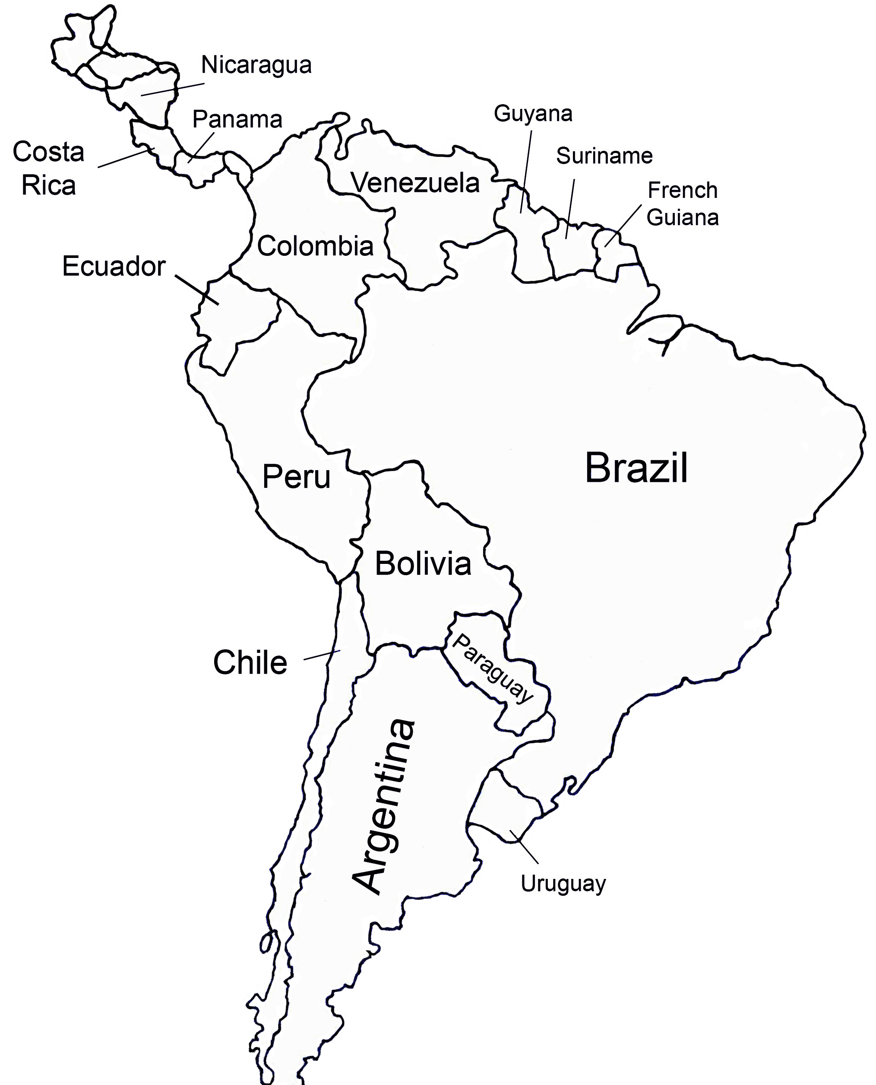

Sloth Species

Two-fingered sloths
Linnaeus’ Sloth
Hoffman’s Sloth
Three-fingered sloths
Maned Sloth
Brown-throated Sloth
Pale-throated Sloth
Pygmy Sloth
uncertain species

Asking Your Own Questions

Now it’s time to ask your own questions that you can answer using iNaturalist data.

In the table below, write some questions about sloths that you wonder about. You will see a sample question to get you started! Then write your ideas about what you THINK will be the answer. Then use the iNaturalist app to find out more about giraffes. When you feel you have found answers, you can write your conclusions in the space provided!

Question | What data do I need to find? | Conclusions
Which sloth species do you think is adapted to the widest range of habitats? | Look for color dots that can be found across the widest area on the map.

Share your questions and conclusions with a teacher or parent. They can help suggest other ways to use the data, or they might help ask other new questions!

